EXECUTIVE SUMMARY

BACKGROUND

Spentex Industries P. LTD is a leading manufacturer of Cotton yarns & Fabrics for cotton industries. The manufacturing facilities are spread out in different parts of the India & Uzbekistan.

The scope of implementation is in India. The specific solution in the scope of this document comprises of Implementation of SAP ECC 6.0 covering Baramati plant.

Spentex Industries Limited

Promoted by CLC
- Acquired the company from the RPG group in January 2004.
- Promoters have more than 35 years of experience in textiles
Largest spinning company in India
- With an installed capacity of about 5.7 lac spindles
- A 65:35 split between cotton & polyester yarn

Venture in manufacturing through acquisition
- Acquired Cimmco spinners (Solapur) in Oct 2003
- Spentex Industries Limited (Baramati )in January 2004
- Ahmedabad unit in Dec 2005
- Indorama Textiles Limited in Feb 2006
- Amit spinning Industries Ltd in May 2006
- Business of Tashkent Toytepa in Aug 2006

Expansion through Organic route
- Cimmco (Solapur): 50,000 spindles
- Spentex (Baramati): 36,000 spindles

Turnaround of Performance
- Cimmco spinners , Baramati and Amit spinning Kolhapur plants were turned around within 3-5 months
- Equity investment by Citi Venture Capital of Rs. 703.0 million in Dec, 2005
- The Ahmedabad unit started production within 4 month of acquisition
- IRTL increased its EBITDA to 164.3 Million in the first quarter after acquisition as comparedto Rs 75.0 Million in corresponding quarter of the previous year
- Spentex Tashkent clocked EBIDTA of Rs 34.0 Million within 15 days of sales
Major products are:
Cotton Yarn
Manufactured from best quality raw cotton, yarns are available in the count size varying from Ne 5s to Ne 40s. Our cotton yarns are very well accepted with the hosiery and woven fabric manufacturers across the globe.
We also manufacture supima yarns made from supima cotton, under licence no. India-47.


Synthetic & Blended Yarn
With combination of cotton, viscous, polyester, etc. in different proportions, desired blends are obtained with count size varying from Ne 5s to Ne 40s. Our synthetic and cotton yarns are very well accepted with the hosiery, woven and industrial fabric manufacturers across the globe.


Cotton Fabric (Grey, Bleached & Dyed)
High quality Fabric in grey, bleached and dyed forms are available for wide applications in home textiles and garments industry.


Synthetic and Blended Fabric (Grey, Bleached & Dyed)
High quality synthetic and blended Fabric in grey, bleached and dyed forms are available for wide applications in home textiles and garments industry.

Rily through acquisition & demonstrated expertise in turning around acquired units

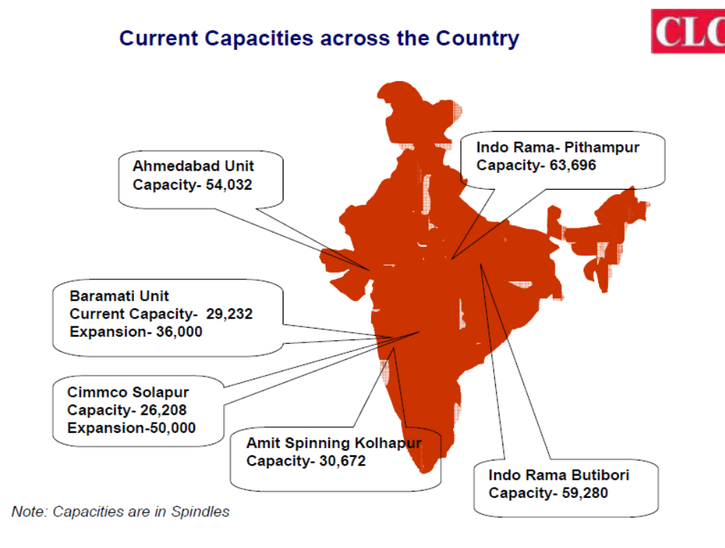

Spentex has decided to implement an integrated ERP solution and have selected SAP ECC 6.0.

The SAP ECC 6.0 Modules, which are being implemented in Phase 1, are

- FI/CO Financial Accounting and Controlling

- SD Sales and Distribution

- PP Production Planning & Control

- MM Materials Management

- QM Quality Management

- WM Warehouse management

- HR Human resources

ENTERPRISE RESOURCE PLANNING (ERP) PROJECT OBJECTIVES.

Objectives for the implementation project are:

- Implement SAP ECC 6.0 standard business processes

- Adhere to business basic's and use SAP as a model for best business practices

- To increase the efficiency.

OVERVIEW OF BLUEPRINT PHASE

This document summarizes the findings of the consulting team, which conducted
Requirement analysis of Spentex industries Ltd for the SAP ECC 6.0 system. The information was gathered through interviews conducted at the Baramati plant with the managers, key users and personnel from Information Systems, as well as through reviews of business processes, business procedures, documentation and relevant reports using Q & A db from Value SAP methodology.
The immediate purpose of the analysis is to prepare to move forward rapidly with the implementation of Spentex industries Ltd

SAP ECC 6.0 system. At the conclusion of the blueprint, the consultants will determine the SAP functionality required to run the Spentex industries Ltd business. The Blueprint and its associated appendices present a summarized perspective of all functional business processes that will be implemented. Blueprint document will serve - from this point forward the dual role of both
official project scope as well as system acceptance criteria.
SAP ECC 6.0 Business Blueprint for
GGPL Controlling Module
Page 8 of 86
The body of this document describes the organizational structure, enterprise area, and SAP ECC 6.0 functional process flows to be implemented at Spentex industries Ltd. Generally, requirements that can be met using standard SAP ECC 6.0 functionality through routine configuration tasks are not explicitly documented. However, certain key requirements are explicitly identified and summarized to highlight their importance to Spentex industries Ltd and to document the approach proposed to meet the requirement.

One section of the report summarizes identified gaps. The project team should discuss this list with agreement on the approach going forward. Acceptable approaches may require:

- Additional programming or technical effort

- Recognition and acceptance of procedural changes ("Workarounds") using standard SAP ECC 6.0 Additional resource commitment

- The deferral of a feature to a later phase

- Simply the recognition and acceptance of a limitation.

The Blueprint reiterates the SAPECC 6.0 organizational structures that have been identified and will serve as the basis for the initial configuration activities. The team believes that SAP ECC 6.0 can accurately model Spentex industries organizational requirements.

No significant configuration choices have been identified that will prevent the future implementation of additional capabilities within the SAP ECC 6.0 environment.

The information gathered and documented in the Blueprint is sufficient for the team to go forward into the Realization phase. However, it is critical that both the consulting team & Spentex team agree on the scope of the project as presented in this document. Acceptance - by both teams - is required to move the project into the next phase.

FI Module introduction.

INTRODUCTION

A FI module is a tool used in Systems, Applications and Products in Data Processing, or SAP. FI modules are used for information technology through SAP, which is a package mainly employed for financial accounting.
The financial accounting (FI) application components fulfill all the international requirement that must made by the financial accounting department of an organization. It provides the following features:

- Management & Representation of accounting data

- Open & integrated data flow

Companies use SAP to integrate, diversify and streamline work. It is a program package offering two main sub-modules: FI and CO. These are used for managing financial information and for analyzing the information.

Integration of FI with other components

Real time integration is nothing but the data posting to all the affected areas instantly when an activity is performed. For E.g. when you do FI-SD integration, when a PGI is posted, the following entry is affected:
1. Cost of Goods Sold Dr 100
to Inventory Account Cr 100
Here the Cost of Goods Sold is an FI entry and Inventory Account related to MM but both of them get affected immediately when you post a PGI in SD.
The updation of these entries when PGI is done is called Real Time Integration. The affect is shown in all FI, MM and SD modules once you save the entry.
The configuration for the below entry is done in OBYC
1. Cost of Goods Sold Dr 100 (T-Key GBB)
To Inventory Account Cr 100 (T-Key BSX)
The automatic entries are posted to inventory accounts through T-keys to which GL accounts are assigned. These T-keys are assigned to movement types in MM. Please refer to T-code OMWN and OMWB for proper understanding.

Sub module of FI:
FI is a sub-module allowing financial transactions to be captured in real time. It allows companies to integrate this information even if the company's current software doesn't allow it. CO is the other sub-module that is part of the FICO module. CO is short for controlling and is used for performing analysis on financial reports and information.
Every posting that is made in the sub ledger generate a corresponding to the assigned G/L accounts. This ensure that the sub ledger are always reconciled with general ledger

Following are the sub components of the FI application which are considered for implementation.

- General ledger (FI-GL)

- Accounts payable (FI-AP)

- Accounts Receivable (FI-AR)

- Bank Accounting (FI-BL)

- Asset Accounting (FI-AA)

Organizational Units

Meaning of OU - "Organizational Units", are administrative-level containers on a computer network that allow network administrators to organize groups of users together so that any changes, security privileges or any other administrative tasks could be accomplished more efficiently.
A network administrator will typically create organizational units that resemble their company's business organization. An OU can be set up for each department. Within that department OU, there could be subsets, or objects that represent users, groups, customers, partners, vendors or even computers and printers on the network.
Applying a set of policies or restrictions to an organizational unit applies it to all subsets within that organization unit. An object, placed into a new organization unit, inherits all the policies and rights associated with that organizational unit.
Organizational Units are used on systems as a form of identity management, a method of technology used to automate various administrative applications such as password synchronization, resetting passwords, user provisioning, Meta directories, and consolidated reporting and auditing.
Company

Company is a voluntary association of persons formed for the purpose of doing business having a distinct name and limited liability. It is a juristic person having a separate legal entity distinct from the members who constitute it, capable of rights and duties of its own and endowed with the potential of perpetual succession. The Companies Act, 1956, states that 'company' includes company formed and registered under the Act or an existing company i.e. a company formed or registered under any of the previous company laws

A company can consist of one or more company codes, Spentex have One company code ST1

Company Code:
T-Code: OX02

The company code is the single most important of all the fundamental definitions in the enterprise structure customization. The company code is the identifier by which a company is referred to in all its transactions. It is an independent accounting entity with 4 numeric characters(although the maximum size fixed for it is 4 digits, a company code can consist of less than 4 digits, however, this is not advisable because, only a company code with 4 digits can take advantage of some of the advanced features available in SAP).
Company name | CO. Code currency | Co. Code.
Spentex Industries Limited | INR | ST1

VARIENT
Variants allow you to save your selection parameters in the input screen.
It minimizes the need to enter selection parameters each time you run a SAP report.
Variants can be sorted for ANY SAP REPORT as long as the Save Button is available in the SAP Menu bar for the report.
Note: Many a transactions may be protected due to security reasons by your administrator and save button may not be available.

Business area.

The business area used in the original posting (particularly when the initial value is not entered) is changed to the correct value in a second step, using an adjustment posting in the general ledger. This may sometimes distribute the posting to several business areas.

You create a customer invoice. The sales revenue must be assigned to several business areas. The receivable is posted without a business area, and a transfer posting is made in a second step.

For Spentex ltd we define following business area:

Business Area | Description
STB1 | Business area for Baramati.
STP1 | Business area for pune.

Segment:
Use
In this IMG activity, you define your segments.
If you then define your profit centers, you can enter an associated segment in the master record of a profit center. The segment is then derived from the assigned profit center during posting.
If you want to derive the segment by other criteria, you can implement a Business Add-In (BAdI). To do this, go to Customizing for Financial Accounting (New) and choose Derive Segment.
Segments for Spentex ltd.

Segments | Description
STCYS1 | Segment for cotton yarn
STFS2 | Segment for fabrics
STSBS3 | Segment for Shirting & bottom ware fabrics
STDS4 | Segment for Denims.

Currency

Transaction Code (OY03)

There are 5 types of currency in SAP r/3 system.
1. Group Currency: You define Group Currency when you define Client (SCC4)
2. Global Company Currency: You define Global Company Currency when you define Company that is assigned to your company code.
3. Hard Currency: YOU define Hard Currency when YOU define the Country that your Company code assigned to. A hard currency is used in countries with high inflation.
4. Index-Based Currency: You define IB Currency when You define Country that your company code assigned to. An index-based currency is stipulated for external reporting (for example, tax returns), in some countries with high inflation.
5. Company code Currency: You define the company code Currency when you define Company Code.
Now with these 5 types of Currency, you can maintain a Parallel Currency in your system under the SPRO – Multiple Currency. SAP gives you to maintain 3 Parallel Currencies, it means when you post a transaction using Trans Currency, system will convert to the others curr. that you set in this setting.

Co. Code | Currency | Description
ST1 | INR | Indian rupee.

Country Key (Y01N)
Values that are used to check entries are defined in the country key.
Length of postal code or bank account number.
The two-character ISO code proposed by SAP is normally used as the country key. Since the definition can vary depending on the customer installation, it is not possible to use the country key for programming in SAP standard programs. If a specific country is to be queried in the program, the ISO code T005-INTCA should be queried instead.
Customers are advised to maintain the ISO code field and, if possible, also the vehicle country key for each country because these fields are queried by programs.
The country keys are defined in the global settings during system implementation. The parameters listed below are dependent on the country key.

Credit Control Area –
Definition -
A credit control area is an organizational unit for specifying and controlling customer credit limits. A credit control area can include one or more company codes. It is not possible to divide a company code into several credit control areas.
Use -
The credit control area is used for credit management in the application components Accounts Receivable (FI-AR) and Sales and Distribution (SD).
You define a credit control area according to the areas of responsibility for credit monitoring. For each credit control area, you enter a key, a name, and the currency in which the credit limit is to be managed in the credit control area. You select a four-character alphanumeric key. In the simplest case, each company code corresponds to one credit control area. In this case, we recommend that you use the same key for the credit control area as for the company code.
Each credit control area carries out credit control for one or more company codes and, to enable it to do this, you must assign the respective credit control area to the company codes.

- Assigning Customer and Credit Control
Customers can be created in different company codes - the credit control area responsible for a given customer depends on which credit control area the company code is assigned. Customers that are created in company codes with a common credit control area are controlled by this one control area for all company codes.
If a customer is created in several company codes that are assigned to different credit control areas, a separate credit limit is managed for the customer in each of the different credit control areas.

Co. Code | Credit control area | Description
ST1 | ST1 | Credit control area for ST1

FUNCTIONAL AREA –
Transaction code: OKBD
Functional Areas within the FI Enterprise structure are used to organize your business for cost of sales (COS) accounting. Functional areas allow you to segregate and classify different types of costs within one expense account. This makes it possible for example, to use a single labor account to determine what amount of labor is spent directly on production as opposed to sales or administration. It is possible to report on functional areas from both FI and Profit Center Accounting.

Co. Code | Functional Area | Description
ST1 | ST1 | Functional area for ST1

Financial management area -
Significance -
Financial Management Area is a customization that helps to work on Cash Flow & Funds Flow Management. Without this customization these features will not be activated.
In this step, you create your financial management (FM) areas. The financial management area is an organizational unit within accounting which structures the business organization from the perspective of Cash Budget Management and Funds Management.
You define the functional characteristics of FM areas separately for both Cash Budget Management and Funds Management in the implementation guide for each of these areas.
To be able to take advantage of the high degree of integration in the SAP system, you must link the FM areas with organization units from other applications. For example: if you assign a Financial Accounting document to a Funds Management object (such as a commitment item or funds center), the system has to determine an FM area, so that it can record the data in Funds Management. For this reason, you must specify how the appropriate FM area is to be determined.

The FM area is taken from the company code when you assign a company code to an FM area. More than one company code can be assigned to an FM area.

Co. Code | Functional Area | Description
ST1 | ST1 | financial management area for ST1

Financial account Basic Setting.

Chart of Account -
It defines the structure of G/L accounts. It is a list of G/L accounts used by one or more company codes. In that Chart of account you have to specify the length of G/L accounts.
In SAP all the entries are document oriented. so from the balance sheet of any entry you can identify the root of an entry. so it's like a flow chart in computer terms.
There are three types of Chart of Account are there.
1. Operative Chart of Accounts
2. Group of Chart of Accounts
3. Country Chart of Accounts.
1. Operative Chart of Accounts is a Chart of Account you use for the company code.
2. For different chart of accounts (operative COA) for different company code, you can group the chart of account into one chart of account for internal reporting, but cross company code controlling is not possible, because of different chart of account for different company code.
3. For different country you can have different reporting system. so for different company code you can have different company code, but can have same Operative Chart of account, so cross company code controlling is possible.

Co. Code | Chart of account | Description
ST1 | ST1 | Chart of account for ST1

G/L Account Group
Definition:
Account group is used to classify g/l accounts of same features in the chart of accounts, for example assets and liabilities .on the other hand , proper number range can be assigned such that accounts of same nature will appear next to each other in the chart of accounts.
When creating a G/L account, you must specify an account group.
The account group determines:
- the interval in which the account number must be
- which fields are required and optional entries when creating and changing master records
- which fields are suppressed when creating and changing master data.
It enables you to control the layout of screens.
You use account groups to combine accounts according to the above criteria (for example, a P&L account group, asset account group and material account group).

Following list of account group for spentex textile group of industries
Chart Of A/C | A/C Group | Descriptions | A/C From | A/C To
ST1 | Fa | Fixed Assets | 1 | 100
ST1 | Ca | Current Assets | 101 | 200
ST1 | Liab | Liability | 201 | 300
ST1 | Cl | Current Liability | 301 | 400
ST1 | Inco | Incomes | 401 | 500
ST1 | Exps | Expenses | 501 | 600
ST1 | Matr | Material | 601 | 700

Field Status

- Definition -
You have to define field status outside of the master record. Mark the field status you need for each field or field group under a field status group. Then assign the field status group to individual G/L accounts in the G/L account master records.
Field status groups are independent of company code, attaching instead to the field status variant. A separate variant exists in each company code for field status groups in the standard delivered system. The variant name is the same as the company code, and each company code is assigned to this variant.
You can work with the same field status groups in more than one company code, as outlined below:
- Maintain field status variant
- Assign company code to field status variant
We have to set the field status for each group by the following three options

- Suppress– which hide the field

- Required entry – Mandatory field

- Optional – Not mandatory.

Following List of Field Status Group to e Used For Spentex Textile
Field Status Group | Description
G001 | General (With text. Allocate )
G002 | Cost account (Internal order req.)
G003 | Bank Account
G004 | Cost Accounts
G005 | Bank Accounts (Obligatory Value Date)
G006 | Material Accounts
G007 | Asset Accts (W/O Accumulated Depreciatn)
G008 | Assets Area Clearing Accounts
G009 | Bank Accounts (Obligatory Due Date)
G010 | Cost Account (Cost center req.)
G011 | Clearing Accounts (With Settlement Per.)
G012 | Receivables/Payables Clearing
G013 | General (Obligatory Text)
G014 | MM Adjustment Accounts
G017 | Freight/Customs Provisions/Clearing (MM)
G018 | Scrapping (MM)
G019 | Other Receivables/Payables
G023 | Plant Maintenance Accounts
G025 | Inventory Adjustment Accounts
G026 | Accounts For Down Payments Made
G029 | Revenue Accounts
G030 | Change In Stock Accounts
G031 | Accounts For Down Payments Received
G032 | Bank Accounts (Obligat.Value/Due Dates)
G033 | Cost Accounts For External Services
G036 | Revenue Accts (With Profit Center)
G039 | Accts For Pmnts On Acct Made For Assets
G040 | Personnel Clearing Accounts
G041 | Tax Office Clearing Accounts
G045 | Goods/Invoice Received Clearing Accounts
G049 | Manufacturing Costs Accounts
G050 | Customer Commission Clearing Accounts
G052 | Accounts For Fixed Asset Retirement
G056 | Amortization Accounts
G059 | Inventory Accounting Material Stock Acct
G062 | Investment Support Accounts
G064 | Other Cost Accounts (Obligatory Text)
G067 | Reconciliation Accounts
G068 | Reconciliatn Accts (Payables - Austria)
G069 | Cost Accounts (Travel Expenses)
G070 | Clearing Accounts (Travel Expenses)
G071 | Reconcil.Accts (KIDNO/Foreign Payment)

Fiscal year Variant – OB29
Fiscal year variant -
The fiscal year variant determines the posting periods to be used by the client's company. SAP allows a maximum of 16 posting periods each fiscal year - normally 12 regular posting periods and 4 special posting periods are used. The special posting periods are used for posting audit or tax adjustments to a closed fiscal year.
We can define following characteristics for a fiscal year variant:
- how many posting periods a fiscal year has
- how many special periods you need
- how the system is to determine the posting periods when posting
When defining your fiscal year, you have the following options:
  - Your fiscal year is the calendar year
In this case, you must only select the Calendar year field.
  - Your fiscal year is not the same as the calendar year and is not year-dependent
In this case, you first enter the number of your posting periods in the Number posting per. field. To define your posting periods, select your fiscal year variant and select Periods on the navigation screen. On this screen, enter the month and the day of the period end and the period in each case.
  - Your fiscal year is not the same as the calendar year and is year-dependent
Enter the number of your posting periods in the field Number posting periods and select the field Year-dependent. To define your posting periods, select your fiscal year variant and select Periods on the navigation screen. The system asks for which calendar year your year-dependent fiscal year variant is valid. You then enter the month and day of the period end for each of your periods, and the periods themselves.
It is also possible to determine names for the periods of a non-year-specific fiscal year variant. To do so, select your fiscal year variant and choose Period texts on the navigation screen. You can specify a three-character abbreviation (Jan, Feb, Mar...) and a 20-character long text (January, February, March).
Defining shortened fiscal year
A shortened fiscal year is a fiscal year having less than twelve months, but for which year-end closing must be carried out. The definition of a shortened fiscal year is always year-dependent, since it represents a year-related exception. You must always define an entire calendar year when defining a fiscal year variant. The year-related fiscal year variant therefore contains not only the periods from the shortened fiscal year, but also other periods from the previous or subsequent fiscal year.
FV | Decription | Yr.Dependent | Calendar yr | No.of posting | No of special period.
S1 | April to march | N | N | 12 | 4

Opening and Closing Posting Periods -

T- Code - OBBO
Use
You define posting periods in your fiscal year variants. You can open and close these posting periods for posting. As many periods as you require can be open for posting simultaneously.
Usually, only the current posting period is open for posting, all other posting periods are closed. At the end of this posting period, the period is closed, and the next posting period is opened.
Special periods can be open for closing postings during the period-end closing.
Variant:
In the standard setting, a separate variant for posting periods is defined for every company code. The name of this variant is identical to the company code name. Every company code is allocated to this variant with the same name. Thus nothing has changed in the system yet: Every company code has its own variant. If you want to and can continue working on this basis (for example, if you manage with only a few company codes), you do not have to make any changes in the configuration.
For the company code ST1 we define following open close posting period
Var. | A | From pr 1 | Year | To period | Year | From Pr 2 | Year | To period | year
ST1 | + | 1 | 2011 | 12 | 2012 | 13 | 2012 | 16 | 2012

